Year 11 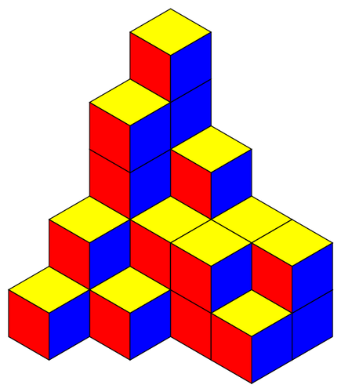
GCSE GROUP SCHEME OF WORK.

This scheme of work is to be used as a guide only. Sometimes due to unforeseen circumstances the class may be a week behind or sometimes may even a week ahead of schedule. The topics will still be covered in the same order.

Term 1
Week 1  Angles. | - Recap of simple angles.  - Angles on a line and about a point.  - Angle systems in parallel lines.
Week 2  Angles in shapes. | - Know the angle sum in a triangle is 180.  - Find missing angles in a triangle.  - Know the angle sum in any quadrilateral.  - Find the missing angle in a quadrilateral.
Week 3  Quadrilaterals. | - Know the properties of squares and rectangles.  - Know the properties of rhombuses and parallelograms.  - Know the properties of kites and trapeziums.
Week 4  Interior/exterior angles. | - Find the interior and exterior angle of any polygon.
Week 5  Bearings and constructions. | - Be able to draw and measure bearings.  - Recognise plans and elevations.  - Use triangular dotty paper to draw in 3D.
Week 6 | - Use this week to catch up on anything missed in shapes.
Week 7  Review and test. | - Review all topics covered this term.  - End of term test.  - End of term activities.

Term 2
Week 1  Measure | - Be able to read scales.  - Know basic measures.  - Be able to estimate measurements.
Week 2  Converting metric measurements. | - Convert between different metric units for length.  - Convert between different metric units for mass.  - Convert between different metric units for volume.
Week 3  Transformations. | - Recap of symmetry.  - Rotate a shape around a given point.  - Translate a shape on a coordinate grid.
Week 4  Transformations. | - Enlarge a shape by a scale factor.  - Congruence and similarity.
Week 5  Scale drawing. | - Interpret scale drawings.  - Construct plans using a given scale.  - Understand and use bearings.
Week 6  Review Week | - Review all topics covered this term.
Week 7  Test | - End of term test.  - Christmas maths activities.

Term 3
Week 1  Factors and multiples. | - Identify and find multiples and common multiples.  - Identify and find factors and common factors.  - Identify and find prime numbers.  - Write a number as a product of primes.
Week 2  LCM and HCF | - Find the LCM of a set of numbers.  - Find the HCF of a set of numbers.
Week 3  Pythagoras’ Theorem. | - Use Pythagoras# theorem to find missing lengths in right angled triangles.
Week 4  Sequences | - Find the term to term rule for simple sequences.  - Recognise and use sequences of suare, cube and triangular numbers.  - Use the nth term to find terms in a sequence.  - Find the nth term.
Week 5  Final teaching week. | - Use this time to recap or teach any topic that needs teaching or recapping.
Week 6  Review and test week. | - Review all topics covered this term.  - End of term test.  - End of term activities.

Term 4
Week 1  Number | - Revise all number work.
Week 2  Shape | - Revise all shape work.
Week 3  Algebra | - Revise all algebra work.
Week 4  Revision | - Revise for next week’s mock test.
Week 5  Test | - Complete a past paper 1.  - Go through paper together.
Week 6  Test | - Complete a past paper 2.  - Go through paper together.

Term 5
Week 1  Past papers. | - Look at past papers for non calculator work.
Week 2  Past Papers | - Look at past papers for calculator work.
Week 3  Revision. | - Revision.
Week 4  Revision | - Revision.
Week 5  Revision | - Revision.
Week 6 | - Exam week.

